**Technical Analysis Report**

**Full Data Dictionary 3**

**Data Quality Notes 6**

**Agents Analysis and Insights 8**

**Customer Analysis and Insights 15**

**Entertainer Analysis and Insights 25**

# **Full Data Dictionary**

**Table name(table content):**

* Column name: column content(data type)

**Agents(entertainer’s agent information):**

* Agentid: unique identifier of each agents(numeric)
* Agtfirstname: agent’s first name
* Agetlastname: agent’s last name
* Agtstreetaddress: agent’s street address
* Agtcity: agent’s city name
* Agtstate: agent’s state name
* Agtzipcode: agent’s zipcode number (numeric)
* Agtphonenumber: agent’s phone number(numeric)
* Datehired: agent’s hired date(date)
* Salary: agent’s base salary, yearly(numeric) *Agent 9 is only 50(data error?)*
* Commissionrate: commission rate(float)

**Engagements(need to ask the company):**

* Engagementid: engagement event between customer and entertainer, unique identifier(numeric), *(missing values, 131 engagement id but only 111 columns, data quality concern?)*
* Startdate: start date of the engagement(date)
* Endate: end date of the engagement(date)
* Starttime: start time of the engagement(datetime)
* stoptime: end time of the engagement(datetime)
* Contractprice: flat contract price (numeric)
* Customerid: id of customer joined this engagement(numeric)
* Agent id: id of agent joining the engagement(numeric)(different agent id and entertainer id match)
* Entertainerid: id of entertainer joined the engagement(numeric)

**Entertainers(entertainer information):**

* Entertainerid: id of entertainer in the company, unique identifier(numeric)
* Entstagename: stage name of entertainer
* Entssn: entertainer SSN(char, because XXX-XXX-XXXX)
* Enstreetaddress: entertainer street address
* entcity: entertainer city name
* Entstate: entertainer state abbreviation
* Entzipcode: entertainer zipcode number(numeric)
* Entphonenumber: entertainer phone number(char, XXX-XXXX)
* Entwebpage: entertainer personal web page (contain nulls)
* Entemailaddress: entertainer contact email address(contain nulls)
* Dateentered: date of entertainer joined the company (date)

**Entertainer_styles(entertainer music style information)**

* Entertainerid: id of the entertainer, can have multiple(each entertainer fit multiple styles)
* Styleid: musical style id number(numeric)
* Stylestrength: musical style strength, from 1-3(numeric) (need to ask company asc or desc)

**Musical_Styles(music style reference table):**

* Styleid: musical style id number, unique identifier(numeric)
* Stylename: name of the music style

**Musical_Perferences(music preference information of each client):**

* Customerid: id of customer (numeric)
* Styleid: musical style id number (numeric)
* Preferencesequence: preference sequence number of each customer's music style, range from 1-3 (numeric) (seem to be same metric as Stylestrength, need to ask company if asc or desc)

**Customers(customer information):**

* Customerid: id of customer, unique identifier(numeric)
* Custfirstname: customer first name
* Custlastname: customer last name
* Cusstreetaddress: customer street address
* Custcity: customer city
* Custstate: customer state abbreviation
* Custzipcode: customer zip code(numeric)
* Custphonenumber: customer phone number(char, XXX-XXXX)

**Entertainer_members( need to ask the company what is a member and what is status, each entertainer can contain multiple member id, and status are different):**

* Entertainerid: id of entertainer in the company(numeric)
* Memberid: id of member(numeric)
* Status: status of member relationship?(need to ask company)

**members(need to ask the company what is a member):**

* Memberid: id of member, unique identifier(numeric)
* Mbrfirstname: member first name
* Mbrlastname: member last name
* Mbrphonenumber: member phone number(char, XXX-XXXX)
* Gender: member gender type, F=Female, M=Male(has 1 null value)

**ztbl(doesn’t know meaning) all ztbl prefix tables**

* Labelcount: number from 1-60, doesn’t know the meaning
* Twelve columns of Month columns: classified if that month is one of the twelve months

# **Data Quality Notes**

1. Salary column of the agent table, Agent 9 is only 50, compared to other agents, which are in the tens of thousands. This can be a data error, or the difference in working age.

2. In the engagement table, the engagement id column shows that *there are missing values, the max number of engagement id is 131,but only 111 columns, data quality concern?)*

3. All types of preference score are ranging from 1-3, but none of the metric is explained. We don’t know if these are 1 being most popular/favored or vice versa.

4. Member and Entertainer status columns are not explained with a binary classification 1 and 2, maybe better to use 1 and 0 to represent the binary relationship.

5. Engagement table has time of engagement stored in two types of date data columns, its Year-Month-Date and its specific hour of start, might consider combining these two columns together. Or there might be a reason for storing this differently, and I need further communication with the company.

6. All phone numbers are stored in char type, considering in the job scenario, you might need to copy-paste the phone number out and call directly, maybe numeric data type is better? Considering that there can not be duplicated phone numbers in the country.

7. There are multiple duplicate rows in the database, including some obvious repetitive duplicates like the member-entertainer table; the status between the same pair of member-entertainers appeared more than one, which is unnecessary.

8.ztbl series tables contain a wide range of problems. First, they are all containing time information about this ztbl, but they are stored in different tables without any key connecting these tables together.

9.ztbl month table has 12 classification columns that specify if the month is a certain month, using a binary classification 1 and 0. However, this specific use of data classification seems unnecessary considering the month data is already included in the year month column. The same logic apply to yearnumber column, monthnumber column, mouthstart and monthend column, all just repeating same information.

10.ztbl month table, month year column is stored in char data type, hence making it extra difficult to write queries like extract(month from monthyear), might consider making it date data type.

11.ztbl date table contains all the dates, what’s that for?

12. Ztbl skip labels just list 1-60, might consider just removing.

13.ztbl weeks same as above. Can use week of year queries.

# 

# **Queries and Analysis**

## **2. Agents Insights**

--Which agents generate the most revenue for TuneWorks?

**SELECT**

*a*.AgentID,

**CONCAT**(*a*.AgtFirstName, **' '**, *a*.AgtLastName) **AS** *AgentName*,

**COUNT**(*e*.EngagementNumber) **AS** *EngagementsHandled*,

**SUM**(*e*.ContractPrice) **AS** *TotalContractPrice*,

*a*.CommissionRate,

*a*.Salary,

**SUM**(*e*.ContractPrice) * *a*.CommissionRate + *a*.Salary **AS** *TotalRevenue*

**FROM** Agents *a*

**JOIN** Engagements *e* **ON** *a*.AgentID = *e*.AgentID

**GROUP** **BY** *a*.AgentID, *a*.AgtFirstName, *a*.AgtLastName, *a*.CommissionRate, *a*.Salary

**ORDER** **BY** *TotalRevenue* **DESC**;

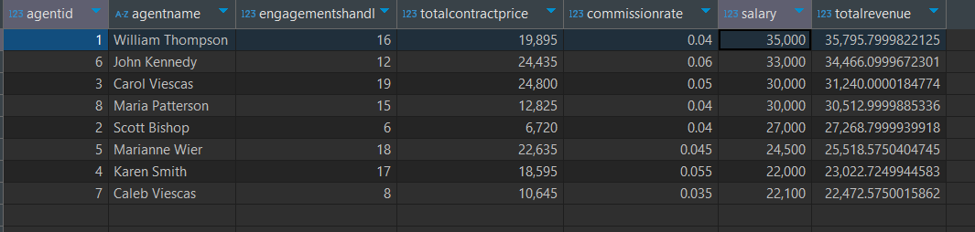

--What musical styles are associated with higher contract prices?

**SELECT**

*ms*.StyleName,

**COUNT**(**DISTINCT** *e*.EngagementNumber) **AS** *NumEngagements*,

**AVG**(*e*.ContractPrice) **AS** *AvgContractPrice*

**FROM** Engagements *e*

**JOIN** Entertainer_Styles *es* **ON** *e*.EntertainerID = *es*.EntertainerID

**JOIN** Musical_Styles *ms* **ON** *es*.StyleID = *ms*.StyleID

**GROUP** **BY** *ms*.StyleName

**ORDER** **BY** *AvgContractPrice* **DESC**;

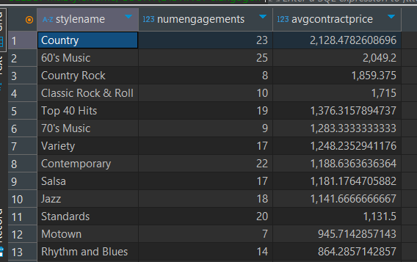

**--How has monthly revenue trended over the past year?**

**SELECT**

**DATE_TRUNC('month', *e*.StartDate) AS *RevenueMonth*,**

**SUM(*e*.ContractPrice) AS *MonthlyRevenue*,**

**COUNT(*) AS *NumEngagements***

**FROM Engagements *e***

**-- WHERE EXTRACT(YEAR FROM e.StartDate) = 2023**

**GROUP BY *RevenueMonth***

**ORDER BY *RevenueMonth*;**

**--ROI**

**WITH *six_months_engagements* AS (**

**SELECT**

***e*.AgentID,**

***e*.ContractPrice,**

***e*.StartDate**

**FROM Engagements *e***

**WHERE *e*.StartDate >= (SELECT MAX(StartDate) FROM Engagements) - *INTERVAL* '6 months'**

**),**

***revenue_per_agent* AS (**

**SELECT**

**AgentID,**

**SUM(ContractPrice) AS *TotalContractPrice***

**FROM *six_months_engagements***

**GROUP BY AgentID**

**),**

***agent_financials* AS (**

**SELECT**

***a*.AgentID,**

***a*.Salary / 2 AS *SemiAnnualSalary*,**

**COALESCE(SUM(*e*.ContractPrice), 0) * *a*.CommissionRate AS *CommissionEarned***

**FROM Agents *a***

**LEFT JOIN *six_months_engagements* *e* ON *a*.AgentID = *e*.AgentID**

**GROUP BY *a*.AgentID, *a*.Salary, *a*.CommissionRate**

**)**

**SELECT**

***r*.AgentID,**

***a*.*SemiAnnualSalary*,**

***a*.*CommissionEarned*,**

***r*.*TotalContractPrice*,**

***r*.*TotalContractPrice* / NULLIF((*a*.*SemiAnnualSalary* + *a*.*CommissionEarned*), 0) AS *ROI***

**FROM *revenue_per_agent* *r***

**JOIN *agent_financials* *a* ON *r*.AgentID = *a*.AgentID**

**ORDER BY *ROI* ASC;**

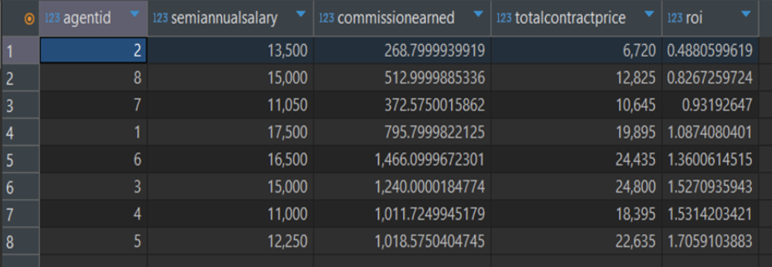

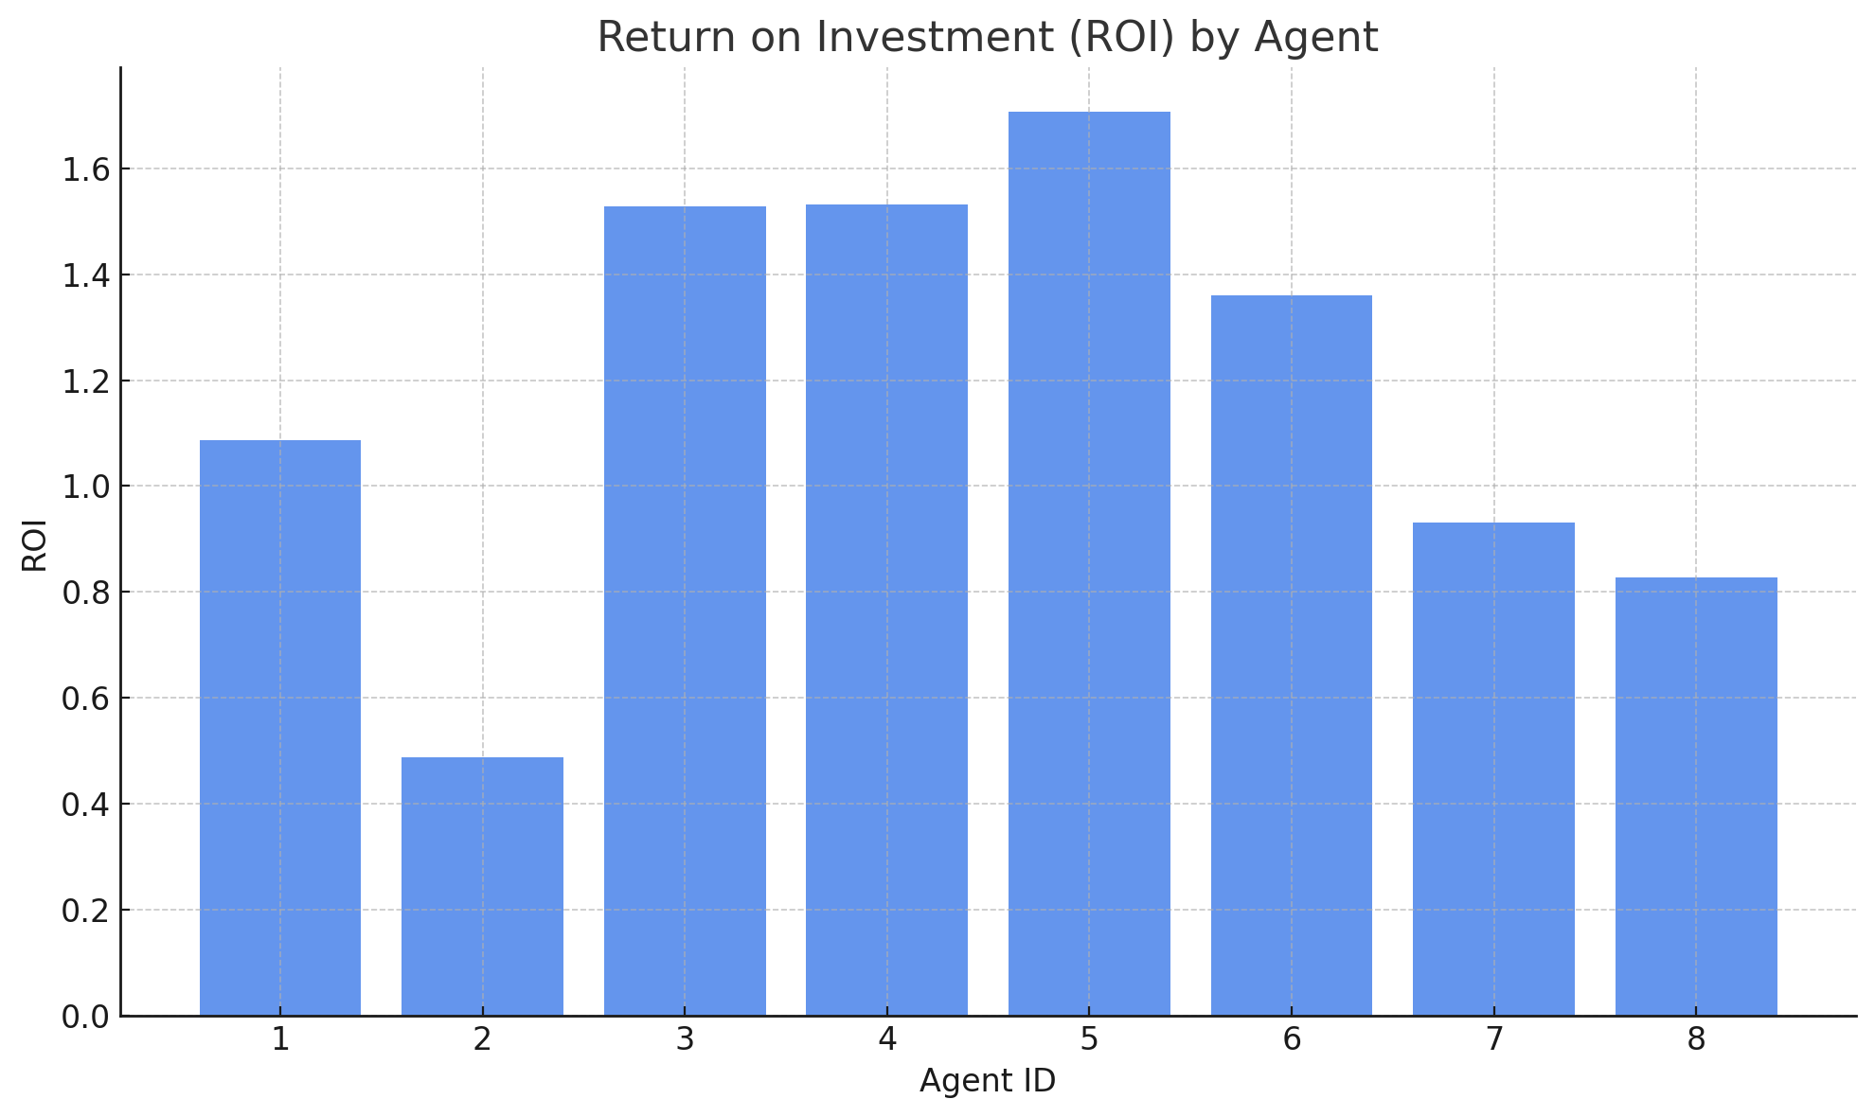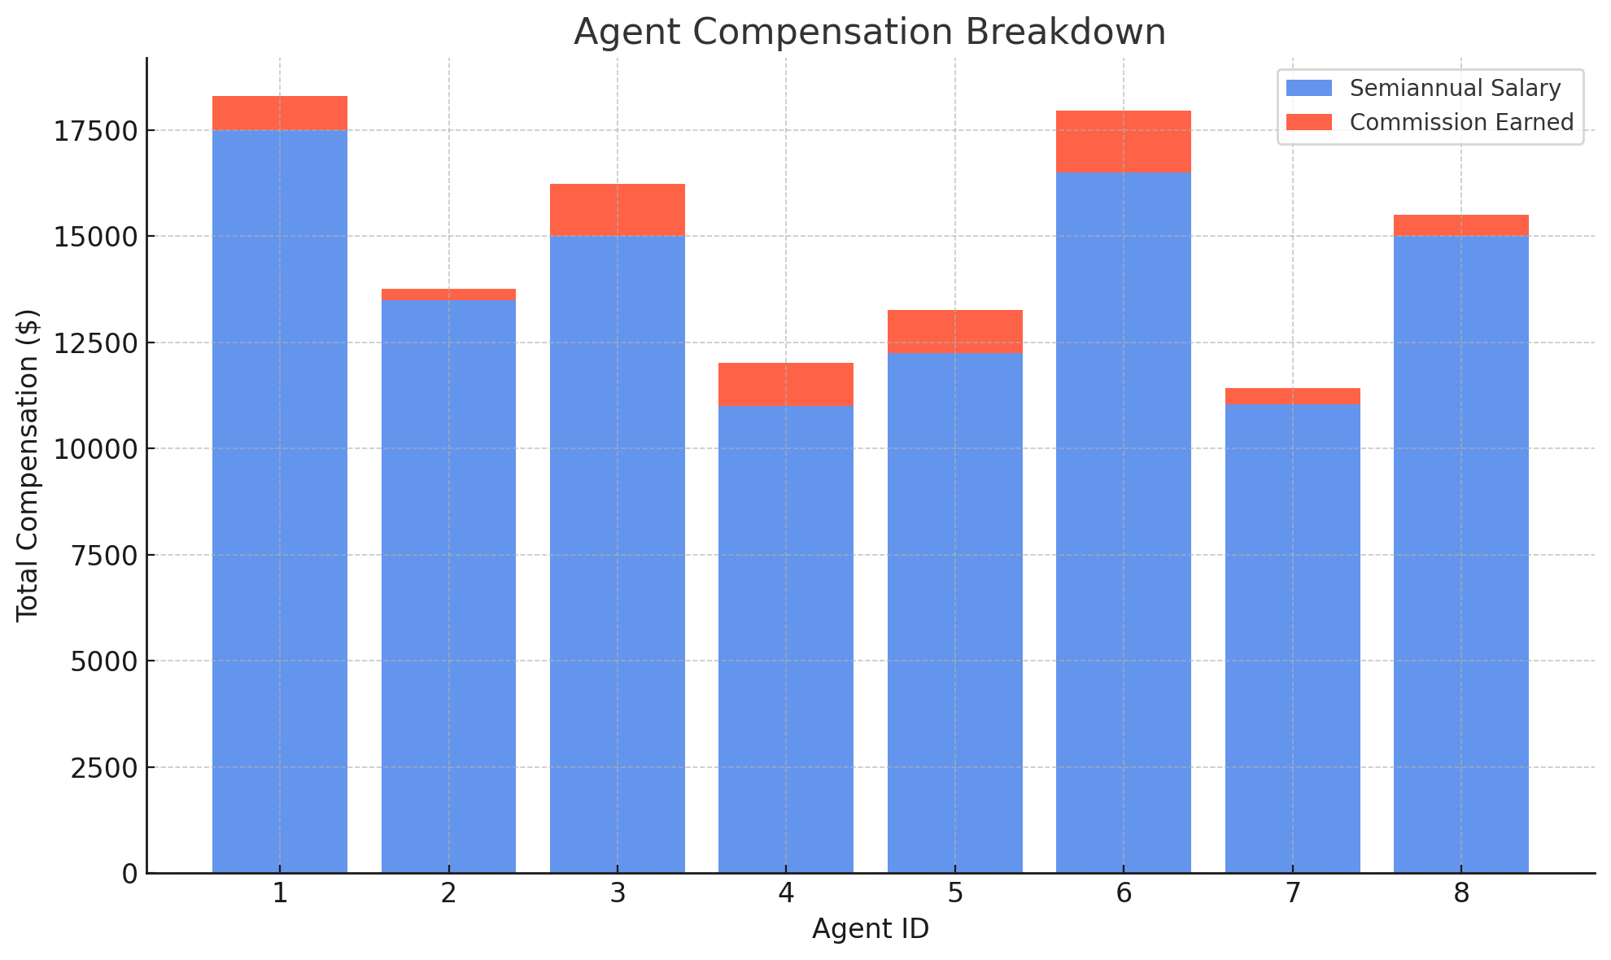

## **2. Agent ROI Analysis & Termination Decision**

### **2.1 Objective**

To determine the financial effectiveness of each sales agent, we analyzed their performance using a unified metric: Return on Investment (ROI). This allowed us to quantify the value each agent brings to the company relative to their compensation.

ROI = Total Contract Price (revenue) / (Semiannual Salary + Commission Earned (cost))

This ratio measures how much revenue an agent generates per dollar paid. A value above 1.0 indicates profitability, while a value below 1.0 indicates a financial loss.

This ratio measures how much revenue an agent generates per dollar paid. A value above 1.0 indicates profitability, while a value below 1.0 indicates a financial loss.

### **2.2 Methodology**

* Data sources were pulled from the salary table, commission records, and engagement contract price fields.
* We filtered for contracts started within the last 6 months using SQL CTEs to ensure relevance to current productivity.
* ROI was calculated per agent and visualized using both a stacked bar chart (salary vs commission) and a ROI bar chart.

### **2.3 Observations**

1. ROI < 1 Agents:
   * Agent 2 had an ROI of 0.49, the lowest among all, suggesting they cost more than double the revenue they generated.
   * Agent 8 and Agent 7 also had ROI values below 1.0 (0.83 and 0.93 respectively), meaning they failed to recoup their compensation in revenue.
   * These agents were paid between $11,000 and $15,000 in base salary, in addition to commission, yet failed to reach break-even.
2. ROI > 1 Agents:
   * Agent 5 (ROI = 1.71), Agent 4 (1.53), Agent 3 (1.53), and Agent 6 (1.36) significantly outperformed their cost.
   * These agents not only covered their compensation but also produced surplus value.
3. Cost Breakdown:
   * The majority of agent cost comes from base salary, not commission.
   * Commission-heavy agents still vary in ROI, indicating that simply paying more commission does not guarantee better performance.

### Special Case: Agent 9

* Agent 9 was missing from the ROI output, but appears in agent tables.
* We suspect Agent 9 may be:
  + A support staff member logged under the "agent" category,
  + An inactive or probationary agent with no recorded contracts in the last 6 months,
  + Or potentially related to Agent 6, as they share a last name in HR records.
* Regardless, Agent 9’s ROI cannot be calculated and warrants further HR follow-up for role clarification or correction.

### **2.4 Conclusion & Action Plan**

We recommend the following actions based on financial evidence:

Based on their ROI falling below 1.0, we recommend terminating Agents 2, 7, and 8, as they represent a net loss to the company. This indicates that each of them generated less revenue than the cost of their compensation, making their roles financially unsustainable for the company moving forward.

In contrast, Agents 4, 5, and 6 demonstrated ROI values above 1.5, significantly outperforming expectations. These agents not only recovered their total compensation but delivered strong net value. We recommend retaining them and considering performance-based rewards or recognition to reinforce and replicate their results.

Agent 9 remains an open case, as they did not appear in our ROI calculations but are present in other internal records. This suggests a possible data integrity issue or an unclassified status. We recommend investigating Agent 9’s role and status to determine whether they are an active sales agent, support personnel, or a misclassified entry.

In summary, we recommend proceeding with:

* Termination of underperforming agents with ROI < 1.0;
* Retention and recognition of top-performing agents;
* Data and HR audit for Agent 9 to confirm classification and activity status.

These steps aim to optimize agent productivity, reduce avoidable costs, and strengthen the financial foundation of our sales operations.

**1.Goal: Find the relationship of agent and company’s revenue**

**Gets the sum of all contract prices for an agent in the year 2017, assuming the contract price for each engagement is the revenue of that engagement. In this case, we use agent 1 as an example.**

**select sum(contractprice) from engagements *e***

**where agentid =1 and extract(year from startdate)=2017;**

**Then compare the the agent’s revenue to the total salary of that agent, adding commission rate*engagement revenue + flat salary.**

**select (select sum(contractprice) from engagements e where agentid =1 and extract(year from startdate)=2017)*(select commissionrate from agents a where agentid=1)+(select salary from agents where agentid=1) as total_salary_agent1;**

**Looking at a few individual agents, it happens that none of these agents's contract revenue is equal or larger than the total salary of that agent. This might be individual cases, a sanity check is needed. Check the total salary and total engagement contract price.**

**select sum(contractprice) from engagements *e*;**

**select sum(salary)from agents *a*；**

**It appears that the total engagement contract money is less than the total salary of the agents. This brings a serious problem, the total engagements range from 2017-2018, but the agent’s salary seems to be annual, there is a gap between the revenue source and money paid to the agents.**

**This might suggest two things either the contract price is based on per day, or the salary component is calculated differently. Or the current company status is purely losing money, might consider firing every agent to minimize cost.**

**– Monthly revenue trend**

**SELECT** *zm*.MonthYear,

**SUM**(*e*.ContractPrice) **AS** *MonthlyRevenue*

**FROM** Engagements *e*

**JOIN** ztblMonths *zm* **ON** *e*.StartDate **BETWEEN** *zm*.MonthStart **AND** *zm*.MonthEnd

**GROUP** **BY** *zm*.MonthYear

**ORDER** **BY** *zm*.MonthYear;

To uncover patterns in customer demand and identify peak revenue months, guiding TuneWorks in marketing, staffing, and pricing strategy

### **Key Findings**

* **January 2018** yielded the **highest monthly revenue** at approximately **$43,880**, likely due to post-holiday events or high-demand periods.
* Strong performance was also observed in **October 2017** and **February 2018**.
* **November 2017 and March 2018** were revenue troughs, indicating seasonal dips or marketing gaps.
* There is a clear **seasonal cycle** with peaks in Q4 and early Q1.

### **Business Implication**

To improve performance across the calendar year:

* **Capitalize on peak periods** (e.g., January, October) by launching high-profile marketing or premium packages.
* Introduce **special promotions or artist incentives during off-peak months** (e.g., March).
* Consider using this pattern to **forecast staffing and inventory** (e.g., for event logistics or customer support).

**3. Customers Insights**

Total rev and bookings per customers

**SELECT** *c*.CustomerID,

**COUNT**(*e*.EngagementNumber) **AS** *NumBookings*,

**SUM**(*e*.ContractPrice) **AS** *TotalRevenue*

**FROM** Customers *c*

**JOIN** Engagements *e* **ON** *c*.CustomerID = *e*.CustomerID

**GROUP** **BY** *c*.CustomerID;

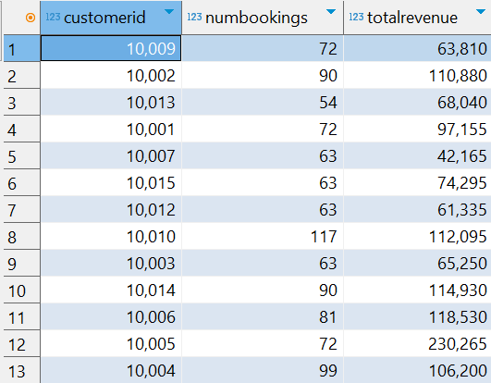

To identify high-value customers based on the total revenue they generated through engagements with TuneWorks performers.

We visualized the results in a bar chart to highlight disparities in revenue contribution across customers

* Customers who have not booked any event pertaining to top 3 musical styles.

**SELECT** **DISTINCT**

c.CustomerID,

c.CustFirstName,

c.CustLastName,

**CASE**

**WHEN** **EXISTS** (

**SELECT** 1

**FROM** Musical_Preferences mp

**WHERE** mp.CustomerID = c.CustomerID

**AND** mp.StyleID **IN** (**SELECT** StyleID **FROM** Top3Styles)

) **THEN** **'Yes'**

**ELSE** **'No'**

**END** **AS** Top3Preference

**FROM** Customers c

**WHERE** c.CustomerID **NOT** **IN** (

**SELECT** **DISTINCT** e.CustomerID

**FROM** Engagements e

**JOIN** Entertainer_Styles es **ON** e.EntertainerID = es.EntertainerID

**WHERE** es.StyleID **IN** (**SELECT** StyleID **FROM** Top3Styles)

)

**ORDER** **BY** Top3Preference **DESC**, c.CustFirstName, c.CustLastName;

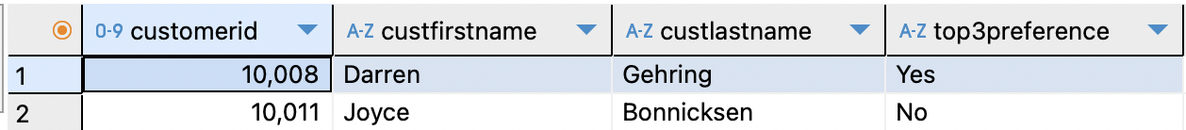

* Inactive Customers (Customers who haven't booked any event)

**SELECT**

*c*.CustomerID,

*c*.CustFirstName,

*c*.CustLastName

**FROM** Customers *c*

**LEFT** **JOIN** Engagements *e* **ON** *c*.CustomerID = *e*.CustomerID

**WHERE** *e*.CustomerID **IS** **NULL**

**ORDER** **BY** *c*.CustFirstName, *c*.CustLastName;

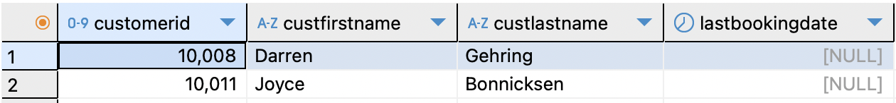

* Customers who have booked most expensive engagements

**SELECT**

*c*.CustomerID,

*c*.CustFirstName || **' '** || *c*.CustLastName **AS** *CustomerName*,

**MAX**(*e*.ContractPrice) **AS** *MaxBookingValue*

**FROM** Customers *c*

**JOIN** Engagements *e* **ON** *c*.CustomerID = *e*.CustomerID

**GROUP** **BY** *c*.CustomerID, *CustomerName*

**ORDER** **BY** *MaxBookingValue* **DESC**

**LIMIT** 10;

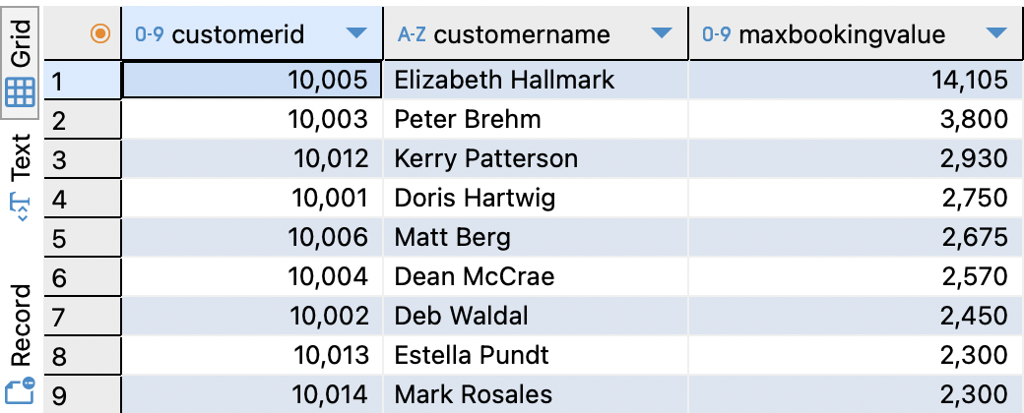

* Customers whose preferences don't match their bookings

**SELECT**

c.CustomerID,

c.CustFirstName || **' '** || c.CustLastName **AS** CustomerName,

ms.StyleName

**FROM** Customers c

**JOIN** Musical_Preferences mp **ON** c.CustomerID = mp.CustomerID

**JOIN** Musical_Styles ms **ON** mp.StyleID = ms.StyleID

**WHERE** **NOT** **EXISTS** (

**SELECT** 1

**FROM** Engagements e

**JOIN** Entertainer_Styles es **ON** e.EntertainerID = es.EntertainerID

**WHERE** e.CustomerID = c.CustomerID **AND** es.StyleID = mp.StyleID

);

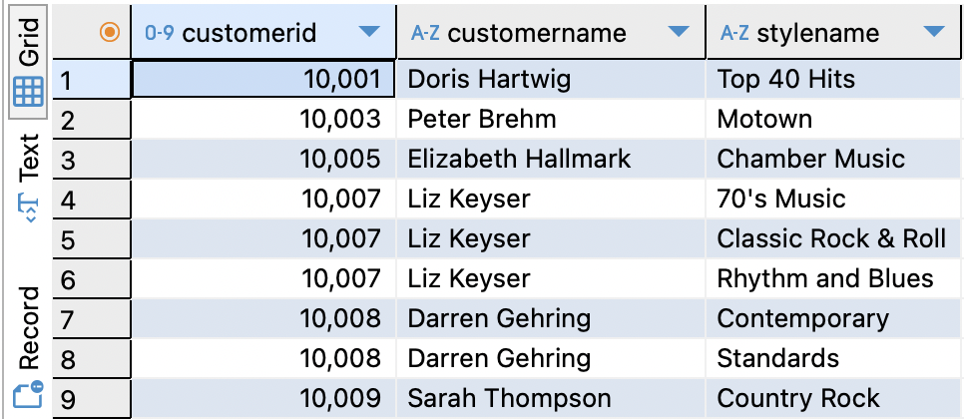

**3.1 Key Findings**

* **Customer 10005** is the most valuable client, generating over **$25,000** in total revenue — more than twice that of any other individual customer.
* **Customers 10002, 10010, 10014, and 10006** each generated between **$12,000–13,000**, suggesting consistent engagement and potential loyalty.
* The revenue distribution is **highly skewed**, indicating reliance on a small group of high-spending clients.
* Two customers haven’t booked any event for the period.
* Many customers exist whose preference music styles does not match with their preferences
* Elizabeth Hallmark has booked the most expensive engagement ($ 14,105) and is well above the other customers in terms of highest engagement.

**3.2 Business Implication**

TuneWorks may benefit from:

In detail: Offer premium or retention perks to **10005**, **10010**, **10002**, and **10004**.Design re-engagement outreach for **10007**.Consider upselling opportunities to medium-tier clients with decent engagement but moderate revenue

* Launching a VIP loyalty program or tiered pricing for its top-spending customers.
* Investigating the needs and preferences of high-revenue clients to optimize retention.
* Developing re-engagement campaigns or upsell strategies for low-spending customers.

#### **Cross-Selling Opportunities:**

* **Focus on Top 3 Styles:**
  + Target customers without bookings in the **Top 3** musical styles (**60’s Music**, **Country**, **Contemporary**) to **expand** their engagement and increase revenue.
  + Use **personalized marketing** based on customer preferences to **highlight** the popularity and exclusivity of these styles.
* **Special Packages and Discounted Tickets:**
  + Introduce **first-time** booking incentives, including **special packages** and **discounted tickets**, to encourage **initial engagement** and reduce barriers for new customers.
  + Promote **bundled offers** that include **Top 3** styles to **upsell** and **cross-sell**.

#### **Re-Engagement for Inactive Customers:**

* **Reactivate Inactive Accounts:**
  + Re-engage customers who **booked in 2017** but not in **2018** to **prevent churn**.
  + Use **VIP access** and **personal invitations** to popular events to **reintroduce** them to the brand.
* **Personalized Outreach for Never-Booked Customers:**
  + Focus on the **2 inactive customers** who have **never made a booking**.
  + Use **free trials**, **test events**, and **personal outreach** to **reduce barriers** and **build loyalty**.

#### **Strategic Marketing Actions:**

* **Segment and Personalize:**
  + Segment these customers based on **musical preferences**, **past engagement**, and **spending history** for **targeted campaigns**.
  + Leverage **email marketing** and **social media** to reach these specific customer groups.
* **Track and Optimize:**
  + Regularly track **conversion rates** and **customer feedback** to **refine** marketing strategies.
  + Use these insights to improve **customer lifetime value** and **repeat bookings**.

**--Total Bookings by City**

**SELECT**

***c*.custcity,**

**COUNT(*) AS *total_bookings***

**FROM Customers *c***

**JOIN Engagements *e* ON *c*.customerID = *e*.customerID**

**GROUP BY *c*.custcity**

**ORDER BY total_bookings DESC**

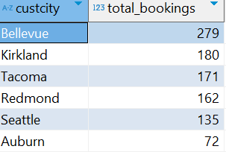

**--Total Revenue by City**

**SELECT**

***c*.custcity,**

**SUM(*e*.contractprice) AS *total_revenue***

**FROM Customers *c***

**JOIN Engagements *e* ON *c*.customerID = *e*.customerID**

**GROUP BY *c*.custcity**

**ORDER BY total_revenue DESC**

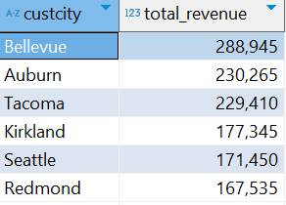

**--Average Revenue per Booking by City**

**SELECT**

***c*.custcity,**

**ROUND(SUM(*e*.contractprice) * 1.0 / COUNT(*), 2) AS *avg_revenue_per_booking***

**FROM Customers *c***

**JOIN Engagements *e* ON *c*.customerID = *e*.customerID**

**GROUP BY *c*.custcity**

**ORDER BY avg_revenue_per_booking DESC**

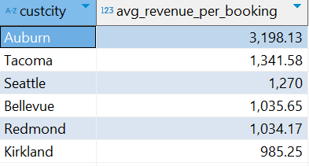

The city of Bellevue currently drives the highest volume of total bookings (31) and also leads in total revenue ($32,105), suggesting strong market activity and customer engagement. However, Auburn presents a surprising insight. Despite having only 8 total bookings, it contributes $25,585 in revenue, leading to the highest average revenue per booking across all cities at $3,198.13. This indicates a smaller, but highly valuable customer base that is willing to pay a premium. In contrast, Kirkland, despite having high booking frequency per customer (10 bookings on average), reports the lowest revenue per booking ($985.25), which suggests that customers there are more price-sensitive or may be engaging with lower-tier entertainers.

**Recommendation:** The company should double down on high-value cities like Auburn by offering exclusive or premium packages tailored to affluent customers. Simultaneously, introduce upselling strategies in Kirkland, such as bundled entertainment services or add-ons to raise revenue per transaction. Bellevue should be maintained as the company's stable base market with consistent campaign presence.

**-- Average Bookings per Customer per City**

**SELECT**

***c*.custcity,**

**ROUND(COUNT(*e*.engagementnumber) * 1.0 / COUNT(DISTINCT *c*.customerID), 2) AS *avg_bookings_per_customer***

**FROM Customers *c***

**JOIN Engagements *e* ON *c*.customerID = *e*.customerID**

**GROUP BY *c*.custcity**

**ORDER BY avg_bookings_per_customer DESC**

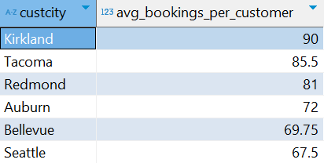

Kirkland also emerges as the most loyal customer base in terms of engagement frequency, with customers booking an average of 10 times per person, followed by Tacoma and Redmond. This suggests an opportunity to build membership programs or loyalty rewards in those areas to further reinforce frequent use. However, when comparing frequency with revenue, cities like Seattle and Bellevue show moderate booking frequency but contribute substantial revenue, indicating a middle-tier audience with upsell potential.

**Recommendation:** Consider launching a tiered loyalty program where frequency-heavy cities like Kirkland get perks for continued engagement, while cities like Seattle receive incentives for higher-tier package upgrades. This dual strategy targets both loyalty and value optimization.

**--Monthly Booking Trend (Unique Customers Booking)**

**SELECT**

**EXTRACT(YEAR FROM e.startdate) AS booking_year,**

**EXTRACT(MONTH FROM e.startdate) AS booking_month,**

**COUNT(DISTINCT e.customerID) AS unique_customers**

**FROM Engagements e**

**GROUP BY booking_year, booking_month**

**ORDER BY booking_year, booking_month**

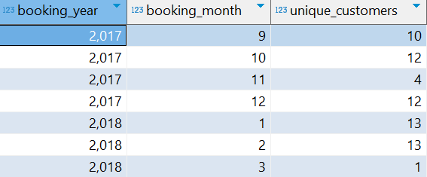

Temporal analysis reveals that booking activity peaked between late 2017 and early 2018, but had a drop off in 2017-11. The engagement activity in the dataset confirms that customers are currently inactive. This suggests either a market saturation, decline in service relevance, or operational issues like entertainer unavailability or agent underperformance.

**Recommendation**: A diagnostic investigation should be launched into why engagement ceased. In the meantime, the company should consider offering reactivation incentives, promotions and re-market to previous customers using email reminders or surveys to understand drop-off reasons.

## **4. Entertainer Insights**

**4.1 Queries and Ouputs**

* + Revenue and bookings by musical styles

**SELECT** *ms*.StyleName,

**COUNT**(*) **AS** *TotalBookings*,

**SUM**(*eg*.ContractPrice) **AS** *TotalRevenue*

**FROM** Engagements *eg*

**JOIN** Entertainer_Styles *es* **ON** *eg*.EntertainerID = *es*.EntertainerID

**JOIN** Musical_Styles *ms* **ON** *es*.StyleID = *ms*.StyleID

**GROUP** **BY** *ms*.StyleName

**ORDER** **BY** *TotalRevenue* **DESC**;

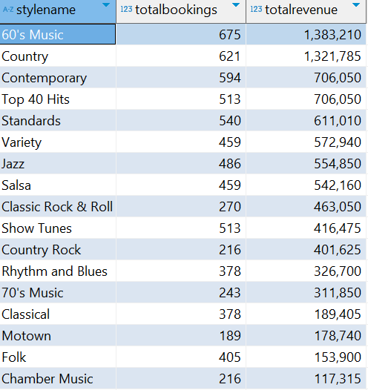

We converted revenue values to percentages and visualized them as a pie chart to clearly indicate the top-performing musical categories.

### **4.2 Key Findings**

The top 4 musical styles — **60’s Music, Country, Contemporary, and Top 40 Hits** — account for a combined **71% of total revenue**:

* **60’s Music** leads with **22%**
* **Country** follows at **21%**
* **Contemporary** and **Top 40 Hits** contribute **11% each**

**4.3 Business Implication**

* **Focus talent acquisition and marketing efforts on the top 4 styles**, as they make up the majority of booking revenue.
* Ensure frequent availability of artists in these styles, especially during peak booking seasons.  
  Monitor underperforming styles (e.g., Salsa and Variety) to decide whether to reposition, reprice, or replace them in the roster.

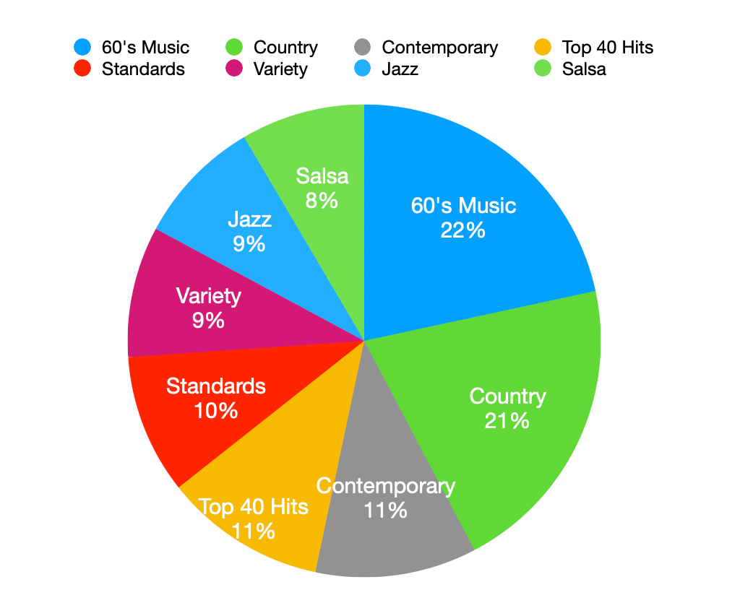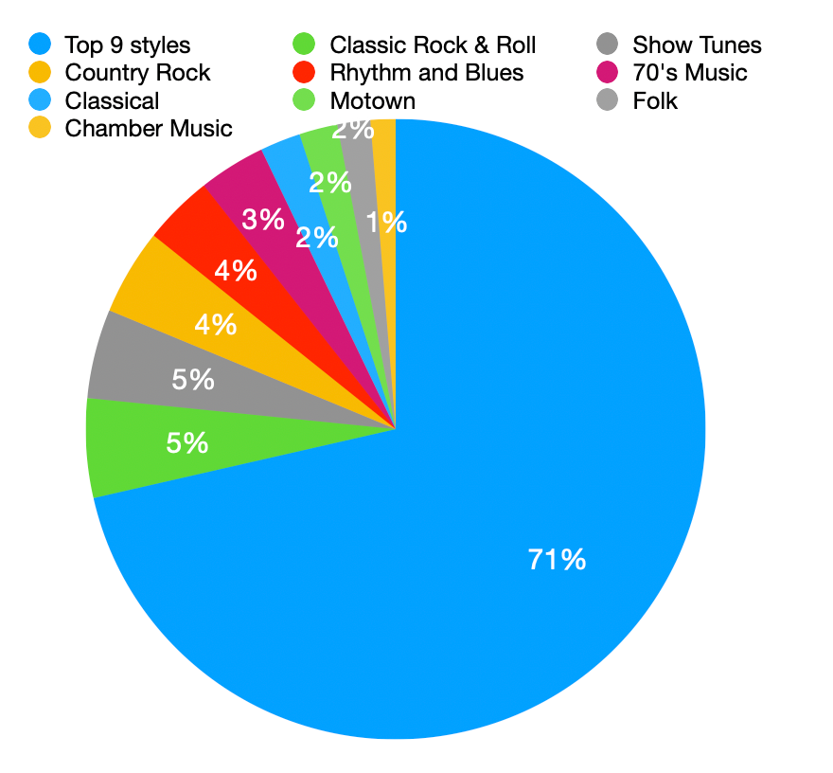

To examine the performance and potential of the musical styles that together contribute 29% of TuneWorks’ total revenue, beyond the top 9 styles.

### **Key Findings**

* While individually small, the remaining **11 musical styles** together contribute **29% of revenue**, showing a **long tail of niche demand**.
* Styles like **Classic Rock & Roll**, **Show Tunes**, and **Country Rock** each contribute ~5%.

**Business Implication**

* **Maintain and optimize representation** for these styles, as they provide **diversification and audience breadth**.
* Use **targeted marketing** to promote niche styles for specific customer segments or event types.

**Entertainers revenue breakdown (Sini)**

**SELECT** *e*.EntStageName,

**COUNT**(*eg*.EngagementNumber) **AS** *TotalBookings*,

**SUM**(*eg*.ContractPrice) **AS** *TotalRevenue*

**FROM** Entertainers *e*

**JOIN** Engagements *eg* **ON** *e*.EntertainerID = *eg*.EntertainerID

**GROUP** **BY** *e*.EntStageName

**ORDER** **BY** *TotalRevenue* **DESC**;

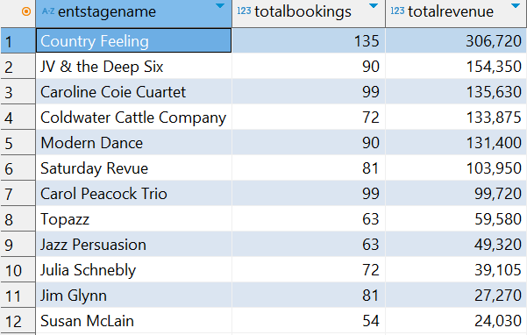

To evaluate individual entertainer performance based on total revenue generated and total number of bookings, supporting data-driven talent management decisions.

### **Key Findings**

* **Country Feeling** leads with both the **highest revenue** and **most bookings** (15+), establishing itself as the top-performing act.
* **JV & the Deep Six**, **Caroline Coie Quartet**, and **Coldwater Cattle Company** show strong performance with moderate bookings but high revenue — indicating good pricing power.
* **Jazz Persuasion**, **Julia Schmebly**, and **Susan McLain** have **low booking counts and revenue**, indicating underutilization or limited appeal.
* **Susan McLain** appears significantly underperforming across both metrics.

**Business Implication**

* **Top entertainers** like *Country Feeling* and *JV & the Deep Six* should receive **priority scheduling, bonuses, or marketing push**.
* Mid-tier acts with high revenue per booking (but fewer gigs) could be **targeted for growth or premium pricing strategies**.
* Low-performing entertainers should be **reassessed** — either repositioned, paired with other acts, or phased out if strategic fit is low.

